|  |  |  |
| --- | --- | --- |
|  |  |  |

GOVERNMENT OF INDIA



**MINISTRY OF SKILL DEVELOPMENT & ENTREPRENEURSHIP**

DIRECTORATE GENERAL OF TRAINI

**NATIONAL SKILL TRAINING INSTITUTE**

NSTI(W),Salt Lake,Kolkata-700091

**CERTIFICATE**

This is to certify that following trainees have completed their project titled

**“NSTI Smart Cloud Campus”**

**For IBM Program – IT, Networking and Cloud (Technical Diploma)**

|  |  |
| --- | --- |
| **Roll Number** | **Name** |
| ADIT19AU01056 | Aditi Sau |
| ADIT19AU04163 | Shweta Roy |

|  |  |  |  |  |  |  |  |  |  |  |  |
| --- | --- | --- | --- | --- | --- | --- | --- | --- | --- | --- | --- |
| |  |  |  |  | | --- | --- | --- | --- | | Ms. Arpita Roy | Mr. K. L. Kuli | Mr. G. C. Ramamurthy | Mr. Sarbojit Neogi | | IBM Faculty | ADIT Director | Principal | Section-In-Charge | |  |  |  |
|  |  |  |  |
|  |  |  |  |

**ACKNOWLEDGEMENT**

We would like to express my sincere gratitude to several individuals and organizations for supporting me throughout my diploma study. First, I wish to express my sincere gratitude to my trainer, Mr. , for her enthusiasm, patience, insightful comments, helpful information, practical advice and unceasing ideas that have helped me tremendously at all times in my study and writing of the project report. Her immense knowledge, profound experience and professional expertise in computer science has enabled me to complete the project successfully.

I also wish to express my sincere thanks to the National Skill Training Institute, Salt Lake for accepting me into the diploma program. In addition, I am deeply indebted to the Ministry of Skill Development & Entrepreneurship and IBM for granting me the diploma course. The technical and financial support has enabled me to complete my diploma course studies successfully. Also, I am grateful the Mr. Sarbojit Neogi faculty of NSTI Salt Lake for supporting me for course completion in the specific subject.

I am also grateful to the following NSTI Regional Director Sir Mr. K. L. Kuli and Principal Sir Mr. G. C. Ramamurthy for their consistent support and assistance.

*Create a Java Server Application in Eclipse and deploy it in IBM BLUEMIX PLATFORM*

**Submitted by**

Aditi Sau Shweta Roy

|  |
| --- |
|  |

***Table of Content***

*Introduction*

*Services and Tools Required*

*Architecture*

*Project Budget*

*Steps & Process*

*Output*

*Conclusions*

*References*

*Create a Java Server Application in Eclipse and deploy it in IBM BLUEMIX PLATFORM*

The WebSphere Liberty architecture shares the same code base as the open sourced [Open Liberty](https://openliberty.io/) (link resides outside IBM) server runtime, which provides additional benefits such as low-cost experimentation, customization and seamless migration from open source to production. Eclipse makes a great local development environment for developing and deploying Java EE applications to Bluemix.

**Services and Tools Required**

**A) Eclipse**

**B) mysql-connector-java-8.0.11-bin.jar**

**C) Tomcat 9.0 server**

**D) IBM Bluemix**

**E) mysql database**

***Architecture:***

USER

ADMIN

INPUT DATA

MYSQL DATABASE

***Project Budget***

Here we don’t need to pay any price for making this project.

***Steps & Process***

**Step: 1 – Creating JSP File**

1. Open eclipse and create a new ‘Dynamic Web Project’

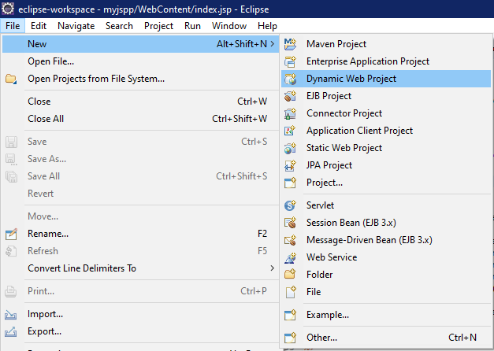

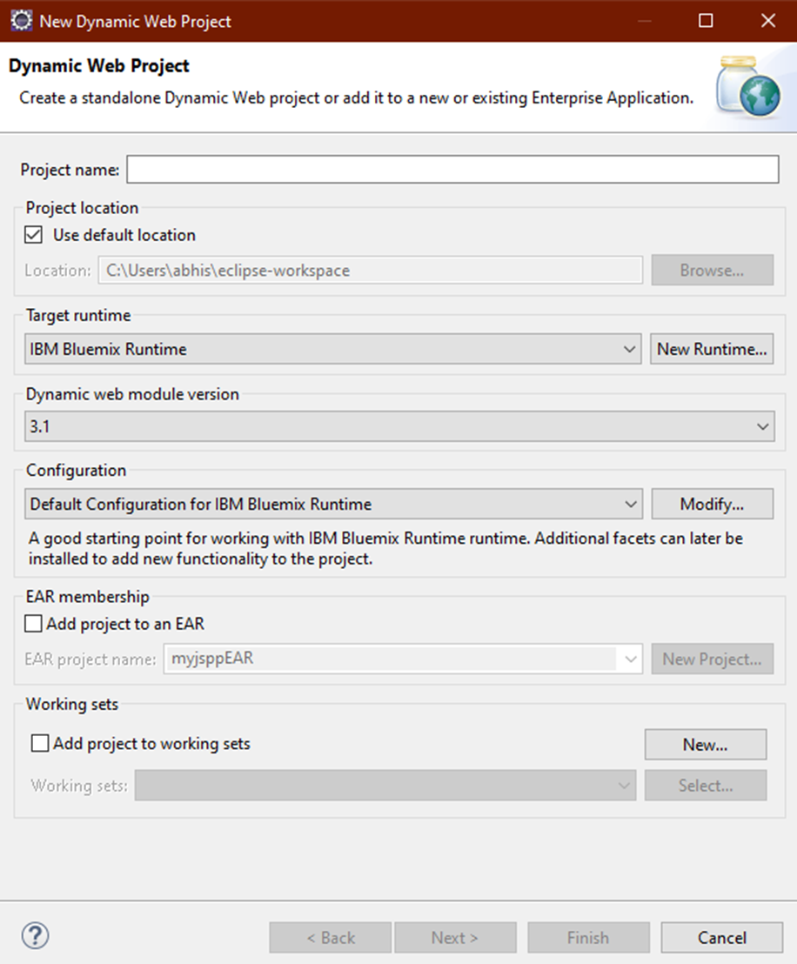

1. After creating the project, right click on the project and select a new jsp file with the name “index. Jsp”

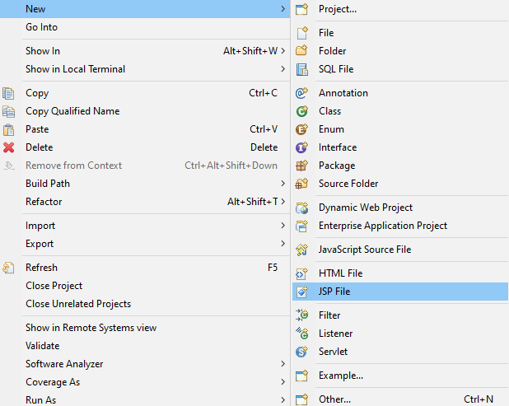

1. And write down the code using file Name “index. Jsp”

<%@ page language=*"java"* contentType9=*"text/html; charset=ISO-8859-1"*

pageEncoding=*"ISO-8859-1"* import=*"java.sql.*"*%>

<!DOCTYPE html>

<html>

<head>

<meta charset=*"ISO-8859-1"*>

<title>Insert title here</title>

</head>

<body>

<form>

<table>

<tr>

<td>Passenger Name</td>

<td><input type=*"text"* name=*"n"*></td>

</tr>

<tr>

<td>Passenger Destination</td>

<td><input type=*"text"* name=*"d"*></td>

</tr>

<tr>

<td>Ticket Class</td>

<td><input type=*"text"* name=*"c"*></td>

</tr>

<tr>

<td>Ticket Price</td>

<td><input type=*"text"* name=*"p"*></td>

</tr>

<tr>

<td>Passenger ID NO.</td>

<td><input type=*"text"* name=*"id"*></td>

</tr>

<tr>

<td></td>

<td><input type=*"submit"* name=*"btn"* value=*"Click For Generate Ticket"*></td>

</tr>

</table>

</form>

<%

String name=request.getParameter("n");

String des=request.getParameter("d");

String cla=request.getParameter("c");

String pri=request.getParameter("p");

String id=request.getParameter("id");

try

{

Class.forName(“com.mysql.jdbc.Driver”);

Connectioncon=DriverManager.getConnection("jdbc:mysql://localhost3306/user","root","Aditisau#1998");

Statement st=con.createstatement();

st.executeUpdate("insert into user(n,d,c,p,id) values('"+name+"','"+des+"','"+cla+"','"+pri+"','"+id+"')");

System.out.println("Hello"+name+" your Destination is "+des+" Your Class is "+cla+" Your Ticket Price is"+pri+" and Your ID number is"+id);

}

catch(Exception e)

{

response.sendRedirect(“error.html”);

}

%>

</body>

</html>

#When the data which we submitted in the database through the form on the Browser is not correct then it showing error by “error.html”.

<!DOCTYPE html>

<html>

<head>

<title>Ticket Information</title>

</head>

<body>

The information is Error

</body>

</html>

**Step: 2- Adding Files & Servers**

A) Next “mysql-connector-java” file paste into “lib” folder for connection

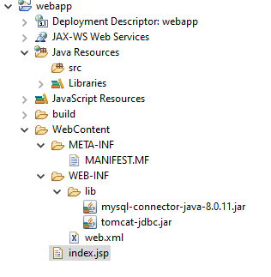

B) Next we have to go “Servers”

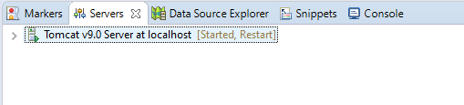

C) And right click on white space then “new” next click “server”



1. Now we have to select “cloud foundry” and click “next”

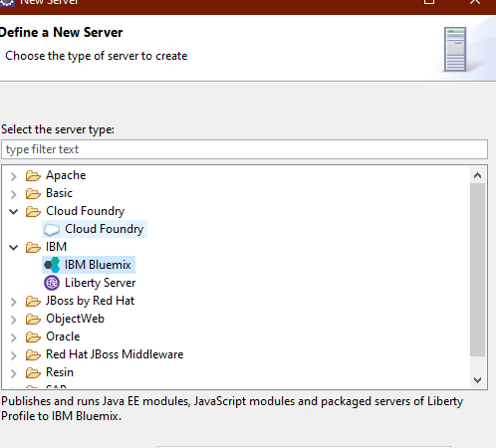

E) Next we have to put Email & Password and click “validate account” then click next

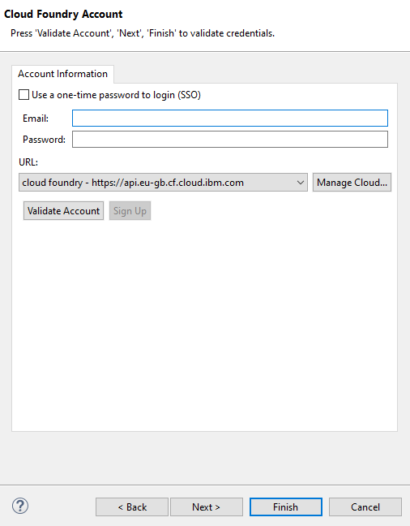

F) Then click “Add” and click “Finish”

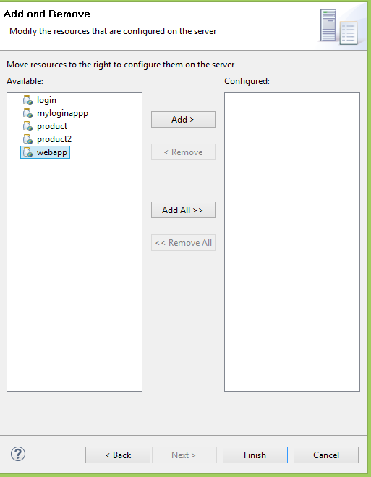

G)Then right click on webapp and click start

H) We have to create mainifest.yml and save it and after that the deploying is start

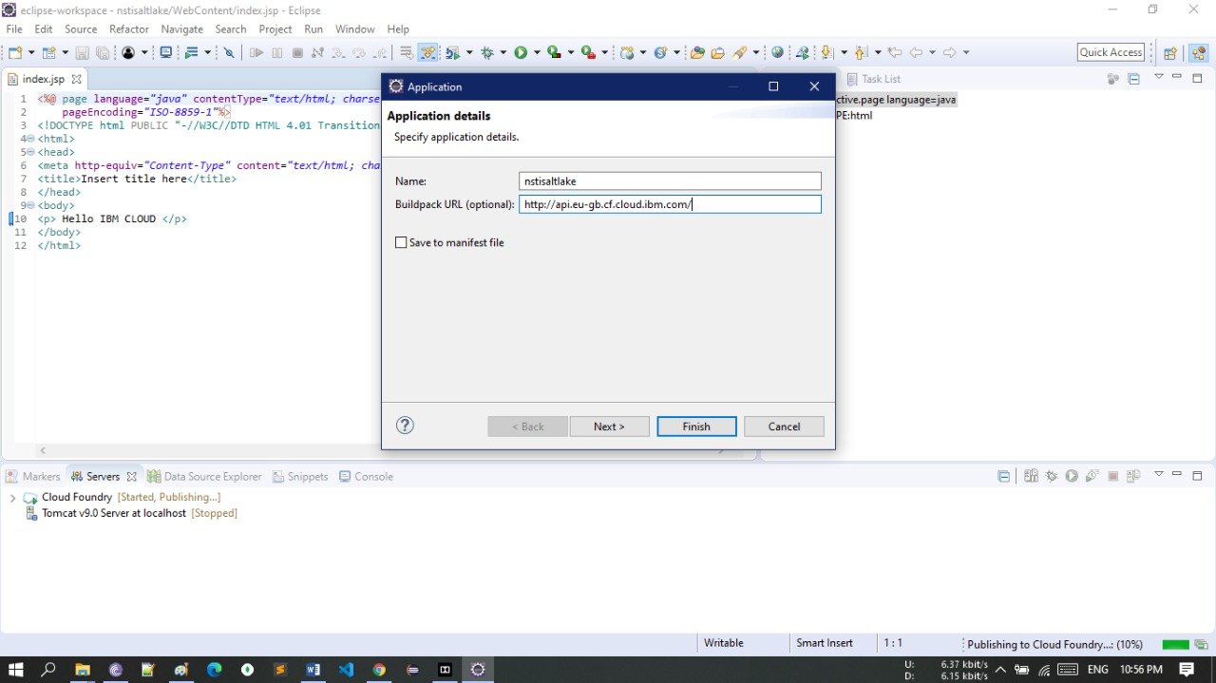

I) After that application will start and we can run it locally by click on “Run on Server”

***Output***

**Step:3 – Getting Output**

A) Now the link on a browser

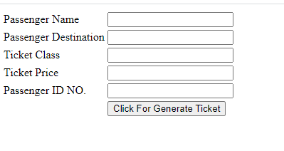

B) Now put data on it and click

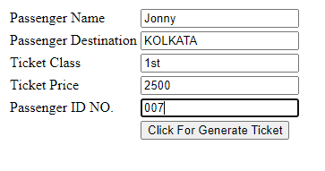

C) Now output will show

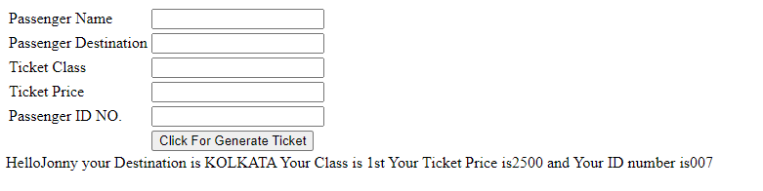

***Conclusions***

Eclipse makes a great local development environment for developing and deploying Java EE applications to Bluemix. This the whole process where I have described in the documentation how I made a web application using jsp /java with the Eclipse, Tomcat , MySQL in the IBM Bluemix.

**REFERENCES**

1.https://dev.mysql.com/downloads/installer/

2. https://www.sitepoint.com/top-5-paas-solutions-developing-java-applications/

**THANK YOU**